**Human Body Size Estimation**

Submitted in fulfilment of the requirements for

Major-Project Sem-VII

By

**Mr. Shriyash Karekar (42)**

**Mr. Aqueel Alam Khan (45)**

**Mr. Imran Ali Khan (46)**

Supervisor:

**Mr. Ashraf Siddiqui**



**Department of Computer Engineering**

**VIDYA VIKAS EDUCATION TRUST’S**

**UNIVERSAL COLLEGE OF ENGINEERING**

**KAMAN, VASAI - 401208**

**UNIVERSITY OF MUMBAI**

**2021-2022**

**Vidya Vikas Education Trust’s**

**Universal College of Engineering, Vasai (E)**

Department of Computer Engineering





**CERTIFICATE**

This is to certify that, the mini project entitled **“Human Body Size Estimation”** is the bonafide work of **Mr. Shriyash Karekar (42), Mr. Aqueel Alam (45) ,Mr. Imran Ali Khan(46),** submitted to the University of Mumbai in fulfilment of the requirement for the mini project of Semester VII project work of B.E. Computer Engineering at Universal College of Engineering, Vasai, at the department of Computer Engineering, in the academic Year 2021-2022, Semester - VII

|  |  |
| --- | --- |
| Mr. Ashraf Siddiqui  **Internal Examiner** | Mrs. Aruna Pavate  **External Examiner** |
| Dr. Jitendra Saturwar  **Head of Department** | Dr. J.B. Patil  **Principal** |

**Major Project-I Report Approval for B. E.**

This project report entitled “Human Body Size Estimation” by Mr. Shriyash Karekar, Mr. Aqueel Alam Khan and Mr. Imran Ali Khan is approved for the Major Project-I Semester VII project work of B.E Computer Engineering at Universal College of Engineering, Vasai, in the academic year 2021-2022.

**Mr. Ashraf Siddiqui Mrs. Aruna Pavate**

**Internal Examiner External Examiner**

**-------------------------------- ------------------------------**

**Date:**

**Declaration**

I declare that this written submission represents my ideas in my own words and where others’ ideas or words have been included, I have adequately cited and referenced the original sources. I also declare that I have adhered to all principles of academic honesty and integrity and have not misrepresented or fabricated or falsified any idea/data/fact/source in my submission. I understand that any violation of the above will be cause for disciplinary action by the Institute and can also evoke penal action from the sources which have thus not been properly cited or from whom proper permission has not been taken when needed.

**Mr. Shriyash Karekar (42)**

**Mr. Aqueel Alam Khan (45)**

**Mr. Imran Ali Khan (46)**

**Date:**

**Abstract**

Online shopping platforms have been attracting many customers since they were introduced in the last decade of the 20th century. Using online shopping platforms, customers can purchase any merchandise anywhere and anytime without the need to physically go from store to store to find a product or wait in lines to check out. Despite their advantages in comparison with in store shopping, customers often have concerns when they shop for products that require measurements estimation such as furniture and clothes. Choosing the wrong clothing size, in particular, is a common issue experienced by many online shoppers. Therefore, in this research, we proposed a model that estimates human body measurements from human real-time pictures using SMPLclassifier and support vector machines.

***Keywords-* Estimate Body Measurements; Image Processing; Support Vector Machine; Brand Sizes; Clothing fit.**

**Contents**

**Abstract III**

**List of figures VIII**

**List of tables IX**

**List of abbreviations X**

**1.INTRODUCTION** **1**

* 1. Project Idea

1. **REVIEW OF LITERATURE 3** 
   1. Survey Existing System
   2. Literature Survey
   3. Problem Statement and Objective
   4. Scope
2. **PROPOSED SYSTEM 8** 
   1. Analysis/Framework/Algorithm
   2. System Requirements
      1. Hardware Requirements
      2. Software Requirements
   3. Design Details
      1. System Architecture 3.3.2 System Modules
   4. Data Model and Description
      1. Entity Relationship Model
   5. Fundamental Model
      1. Data Flow Model
   6. Unified Modelling Language Diagram
      1. Use Case Diagram
      2. Activity Diagram
      3. Sequence Diagram
      4. Component Diagram
      5. Deployment Diagram
   7. Methodology
3. **RESULT 22** 
   1. Proposed System Result
   2. Comparison between existing and proposed system

**Conclusion 25**

**Appendix 26**

**References 27**

**Acknowledgement 29**

**List of Figures**

|  |  |  |
| --- | --- | --- |
| **Figure Number** | **Title** | **Page Number** |
| 3.1  3.2  3.3  3.4  3.5  3.6  3.7  3.8  4.1  4.2 | System Architecture of Webapp  Entity Relationship Diagram  DFD Level 0  DFD Level 1  DFD Level 2  UML  Activity Diagram  Sequence Diagram  GUI Prototype Command Input | 11  14  15  16  17  18  19  20  22  23 |

**List of Tables**

|  |  |  |
| --- | --- | --- |
| **Table Number** | **Title** | **Page Number** |
| 2.1  4.1 | Research Gap  Comparison between existing and proposed system. | 5 - 6  23-24 |

**List of Abbreviations**

**AR & VR:** Augmented reality & Virtual Reality

**ANN:** Artificial Neural Network

**K-NN:** k-Nearest Neighbour

**K-NN:** Support Vector Machine

|  |  |  |
| --- | --- | --- |
|  |  |  |

**Chapter 1**

**Introduction**

In these modern times, we do prefer online shopping as it saves our time rather than visiting stores. But when it comes to buying clothes, we mostly prefer going to the store. This is due to size issues that we face. Nowadays, even most of the brands usually have different standards of clothing sizes.

**1.1 Project Idea**

Users that shop for clothes online need to select the appropriate clothing size from available options. This is particularly a problem because different cloth brands define sizes differently. Many users struggle to estimate their size when they view a brand for the first time, while many other users have difficulties remembering their clothes size even after several purchases from a given brand. The effort for the user to find a measuring tape and manually perform measurements adds to the number of steps prior to finalizing a purchase, and at worst, can cause frustration such that the user abandons the purchase attempt. The problem is less severe at physical stores where a user can easily request a measurement to be performed (or perform self-measurement by requesting the store clerks for a measuring tape). Nevertheless, even at a store, measuring the body size and matching it against a particular brand’s definition of sizes adds to the number of steps needed to make a purchase decision and interrupts the purchase flow. Although augmented reality (AR) measurement apps exist, the user has to be aware of the existence of such apps, which may not be the case when a purchase decision is about to be made. Also, such apps require installation, configuration, and activation by the user, which adds to and the number of steps needed to finalize a purchase. Although the website of a brand can, in theory, request user permission and upon permission, activate an available AR app on the user’s device, doing so interrupts the purchase flow.

**1.2 Project Scope**

In our project, we are going to propose a model which takes 2D images as input, processes it and classifies it into different sizes (X, XL, M, L …) and displays it based on the brand the user selects. So accordingly, datasets would be produced which includes detailed information about various constraints that determine the body features. For implementation we will be using computer vision more specifically SMPLClassifier to detect the human body sizes. In this, a detector will be designed such that one will identify the upper body, another will identify lower body and the last one will identify the full body. After detecting it will extract the features by segmenting each image into 40 parts to estimate shoulder width, waist circumference and all. It is then fed into the K-NN model for predicting size of clothes based on estimated measurements.

**Chapter 2**

**Literature Survey**

A literature survey was carried out to find various papers published in international journals such as IEEE etc. related to estimating size and to get the best algorithm for the same.

**2.1 Survey Existing System**

Estimating body measurements from 2D images is a very challenging task and only a small number of studies investigated this particular problem. While the rest of the studies used more complex and in-depth cameras to obtain 3D images that then are used to estimate the body measurements. In this section, we present the research effort that focus on estimating clothing size or body parts measurements using 3D and 2D images.

The existing approaches for Human body size estimation are:

* Processing 3D images by capturing it through … which is common
* Extracting features from silhouettes using Multi-Dimensional Modeling
* Using AR & VR technologies with the help of body segmentation
* Virtual Garment try on which uses Naive Bayes based modeling
* Computer Vision to detect body parts

Wei-Yi Chang and Yu-Chiang Frank Wang proposed a novel framework for body shape and measurement estimation, which only requires 2D clothing images as input data. The proposed algorithm can be viewed as constructing a parametric model, which recovers body shape images using information observed across different camera views. More specifically, their method focuses on reconstructing the body shape with both multi-view image and measurement guarantees. Different from prior approaches, this method does not require the coefficients for image reconstruction to be the same across camera views, while they introduce additional constraints on the observed measurements for improved estimation. In their work, they consider five different measurements which are popular used in online shopping websites such as two vertical measurements (i.e., overall height and inside leg length) and three horizontal measurements (chest width, waist width, and hip width) are considered. Quantitative and qualitative experiments on a 2D clothing image dataset supported the use of approach, which was shown to perform favorably against single-view or baseline approaches.

D. M. Anisuzzaman, Md. Hosne Al Walid, A. F. M. Saifuddin Saif have proposed a system for human body size estimation using image processing techniques, the proposed system has been introduced to recognize feature points, which has been used to calculate the cloth sizes .To implement the system they have pre-processed the image using Canny Edge Detection Operator to improve the image and suppress unwanted distortion. A light and plain background color has been used for data collection. Different types of algorithms have been used for noise removal. They have extracted some features by using Kollman’s distribution algorithm. In this proposed system, they have extracted five features, but due to inaccurate values they have used only two features for measuring the size of t-shirt and could not implement full body size.

Sahar Ashmawi et al. Proposed an approach that aims to improve and facilitate the experience of online shopping through estimate the human body measurements from 2D images by photographing the body using a smartphone camera. The experiment was conducted on a sample of volunteers who were photographed, manually measured, their real clothing size were reported to compare the result with the model predict size. For implementations, they used one of the computer vision pre-trained algorithms (SMPLclassifier) to detect the human body in images. The detectors are designed to identify three parts of the human body: one detector used to detect the upper body, another detector used to detect the lower part from the body, and the last detector used to detect the full body. After detecting the body major parts, they extracted features by segmenting each image into 40 parts and determine two points as focal points of each body part to estimate the shoulder width, bust circumference, waist circumference, and hip circumference. After that, they used several machine learning models that are trained on a dataset consists of measurements for predicting the size of clothes depending on the estimated measurements. Each model was trained to predicate size a piece of clothing. The results showed that most of the sizes that were predicated are some differences to the real extent of participants. They were unable to consider the side images which had a big toll on their model.

D. M. Anisuzzaman et.al proposed a model for the cloth size prediction and virtual try on, the pressure sensing technique was introduced by Donghua University, China. Factors affecting these models were the type of clothes and fabric properties and the garment pattern which seems affective. They designed two experiments and defined a database based on these experiments and fed it to the Model which uses Naïve-Bayes Algorithms. The software CLO 3D is applied to measure digital clothing pressures. Nine female subjects with representative body shapes are selected for performing real try-on and body dimension measurement. 72 pairs of straight pants, which cover most of pants’ sizes, are involved in the real try-on experiments for data collection.

John Mayes et al. proposed a model for the Real-time Estimation of measurement, This disclosure describes techniques that enable a user to measure body dimensions relevant to clothing size, e.g., chest, waist, inseam, etc., based on capturing images of the user. The techniques can be implemented using the camera and the browser of the user’s device, such that clothing-size measurement is frictionless integrated with the online shopping experience.

**2.2 Research Gap**

We have examined various research papers in the domain of Human Body Recognition for our project to delve deeper into the details of the various researches conducted in the field of Human Body Recognition. Table 2.1 shows a survey of the research paper done for the project.

Table 2.1 – Research Gap

|  |  |  |  |  |  |
| --- | --- | --- | --- | --- | --- |
| **PAPER** **NAME** | **YEAR OF**  **PUBLICATION** | **AUTHOR** | **PUBLICATION** | **PROPOSED**  **WORK** | **Research Gap** |
| Seeing through the Apperance | 2015 | Wei-Yi Chang,  Yu-Chiang, Frank Wang | IEEE | Estimates measurements of body from extracted features from silhouettes and image parsing using  Multi-view Body Shape Modeling with Measurement Constraints. | Scope is limited to silhouettes. Had Satisfactory Accuracy |
| Garment Fit Evaluation Using Machine Learning Technology | 2018 | Kaixuan LIU,  Pascal Bruniaux,  Xianyi Zeng,  Xuyuan Tao | Elsevier B.V. | Fit evaluation is a virtual garment try on which uses Naive Bayes based model to evaluate garment fit. Its output was to show whether the cloth is fit or unfit. | Lack of data set at that time, defining only fit or unfit was way too simplified to give results and the digital pressure sensing was not effective with motion of body |
| Fitme: Body Measurement Estimation using Machine Learning Method | 2019 | Sahar Ashmawia Maram Alharbi Ameerah Almaghrabi  Areej Alhothali | Elsevier B.V | Estimates human body measurements from human real-time pictures using Haar Cascade classifier and support vector machines | The side images of body were not considered resulting into some impact on accuracy. |
| Online Trial Room based on Human Body Shape  Detection | 2019 | D. M. Anisuzzaman  Md. Hosne Al Walid  A. F. M. Saifuddin Saif | International Journal of Image, Graphics and Signal Processing  (IJIGSP) | A Web based application to estimate human body dimensions from 2D image using image processing techniques. | Accuracy of proposed system was not achieved |
| Realtime Clothing Size Estimationusing Body Segmentation | 2020 | John Mayes | Technical Disclosure Commons | Using AR to obtain the size measurement of body with the help of body segmentation | The model asks for height input from user and also the noisy background can alter the output. |

**2.3 Problem Statement and Objective**

Nowadays online shopping is in a great boom, but when it comes to buying, we are often in doubt about our cloth size. Most of the brands have their different standards for Clothing sizes. Even if you want to know our body measurements, we need to visit the tailor. So, with the help of the Human Body Size Estimator, we will try to overcome these problems using just our cell phones.

**2.4 Project Scope**

In our project, we are going to propose a model which takes 2D images as input, processes it and classifies it into different sizes (X, XL, M, L …) and displays it based on the brand the user selects. So accordingly, datasets would be produced which includes detailed information about various constraints that determine the body features. For implementation we will be using computer vision more specifically SMPL to detect the human body sizes. In this, a detector will be designed such that one will identify the upper body, another will identify lower body and the last one will identify the full body. After detecting it will extract the features by segmenting each image into 40 parts to estimate shoulder width, waist circumference and all. It is then fed into the K-NN model for predicting size of clothes based on estimated measurements.

**Chapter 3**

**Proposed System**

This chapter includes a brief description of the proposed system and explores the different modules involved along with the various models through which this system is understood and represented.

**3.1 Analysis/Framework/ Algorithm**

k-NN is one of the most basic classification algorithms in machine learning. It belongs to the supervised learning category of machine learning. k-NN is often used in search applications where you are looking for “similar” items. The way we measure similarity is by creating a vector representation of the items, and then comparing the vectors using an appropriate distance metric (like the Euclidean distance, for example).

It is generally used in data mining, pattern recognition, recommender systems and intrusion detection. KNN classifier is best suited for classifying persons based on their images due to its lesser execution time and better accuracy than other commonly used methods which include Hidden Markov Model and Kernel method. Although methods like K-NN algorithms are proved to be more accurate than KNN classifiers, KNN classifiers have a faster execution time and are more dominant than K-NN. The simplest classification scheme is a nearest neighbour classification in the image space. Under this scheme an image in the test set is recognized by assigning to it the label of the closest point in the learning set, where distance is measured in image space. The Euclidean distance metric is often chosen to determine the closeness between the data points in KNN. A distance is assigned between all pixels in a dataset. Distance is defined as the Euclidean distance between two pixels.

K-NN is a type of instance-based learning, or lazy learning where the function is only approximated locally and all computation is deferred until classification. The k-nearest neighbour algorithm is amongst the simplest of all machine learning algorithms: an object is classified by a majority vote of its neighbours, with the object being assigned to the class most common amongst its k nearest neighbours (k is a positive integer, typically small). If k = 1, then the object is simply assigned to the class of its nearest neighbour.

Step 1: Calculate d(x, xi) where i = 1 to n and d = Euclidean distance between the points.

Step 2: Arrange the calculated n Euclidean distances in non-decreasing order.

Step 3: Let k be a +ve integer, take the first k distances from this sorted list.

Step 4: Find those k-points corresponding to these k-distances.

Step 5: Let ki = the number of points belonging to the ith class among k points i.e. k ≥ 0

Step 6: If ki >kj  i ≠ j then put x in class i

**3.2 System Requirements**

This section will provide the user the required specification of the hardware and software components on which the proposed system is to be implemented.

**3.2.1 Hardware Requirements**

This subsection will provide the minimum requirements that must be fulfilled by the hardware components. The hardware requirements are as follows: -

* A smart phone with
  + - 1. Camera – minimum 10 megapixels
      2. Storage – minimum 200 megabytes free
      3. RAM – minimum 2 gigabytes
      4. Processor – minimum dual core
* A desktop with
  + - 1. RAM – minimum 2 gigabytes
      2. Storage – minimum 100 gigabytes
      3. Processor – Any

**3.2.2 Software Requirements**

This subsection will provide the versions of software applications that must be installed.

The software requirements are as follows: -

Latest installed Browser

* Latest installed Browser
* Python 3.7
* Python IDE
* Internet connection

Mobile should be connected to the internet to make use of the app efficiently.

**3.3 Design Details**

In design details, we analyse the System Architecture and System Modules in detail. We study the flow and process of the entire project in order to develop the project in an orderly and systematic manner. There are 3 modules in Human Body Size Estimation- User input, Feature Extraction, Classifier Model

### System Architecture

In Human Body Size estimation, initially the input gathering will be done from the webapp. If the image is proper enough to be processed it will proceed to next step or else go to error state. After that mapping of an input image into 3D model is done. Measurements from 3D model will be extracted and will go into classification model and displays output on webapp

In figure 3.1, we show the detailed system architecture.

Figure 3.1: System Architecture

### Details of Modules

Human Body Size Estimation tends to integrate various modules in order to facilitate the extraction of measurements and increase the efficiency of the classifier.

The modules are:

* User input
* Feature Extraction
* Classifier Model

## **A. User inputs**

1. Take input from camera / Upload the image
2. Detect full body according to specifications

Webapp will act as an interface between user and background process. In this input will to processed to the next stage likewise output will be displayed.

Take input from camera / Upload the image:

Initially, if the user wants to buy cloths, he has to capture the image through webapp’s camera by following the instructions given. The image will be captured if the conditions are satisfied or else user will be asked to recapture it.

Detect full body according to specifications:

Conditions such as the image captured should be at some specified distance from the camera, the body parts should be clearly visible etc. will be considered before processing. If this condition are satisfied image will be processed to further stage else it will display error message and will be prompted to recapture the image.

## **B. Feature Extraction**

1. Mapping of input image onto 3-dimensional model
2. Extracting body measurements from the reconstructed model.

Mapping of input image onto 3-dimensional model using 3D human reconstruction:

We will encode the 3D mesh of a human body using the Skinned Multi-Person Linear (SMPL) which will create realistic 3D model of the human body that is based on skinning and blend shapes and is learned from thousands of 3D body scans. So, this model will reconstruct the 3D human model.

Extracting body measurements from the reconstructed model:

For extracting body measurements from reconstructed 3D model, we will be using Anthropometric body reshaping and extraction techniques.

## **C. Classifier Model**

Results will be rounded off and the value obtained for parameters will be of height, waist, belly, chest, wrist, neck, etc. These parameters will be fed into classification model. The classification model will classify based on the parameters obtained with the standardized clothing size and will give appropriate results into S, M, L, etc. The result obtained from classification model will be displayed to the user on the webapp.

## **3.4 Data Model and Description**

Data Model describes the relationship and association among data which includes Entity Relationship Model.

**3.4.1 Entity Relationship Model**

Figure 3.4 shows the Entity Relationship Diagram of the proposed system. Entity Relationship diagram is a data modelling technique that graphically illustrates an information system’s entities and the relationships between those entities. Here, the entities are: -Data inputs, Validating Conditions, Feature extraction and Classifier. The diagram shows the different attributes of these entities and also shows the relationship among these different entities.

An entity relationship diagram shows the relationships of entity sets stored in a database. So as our project is Size Estimation, our project has internal calculation which doesn’t take many details about user other than physical data such as measurements of different body parts. The entities used are Data inputs, Conditions, Feature Extraction and Classifier for now. Every entity has different useful attributes.

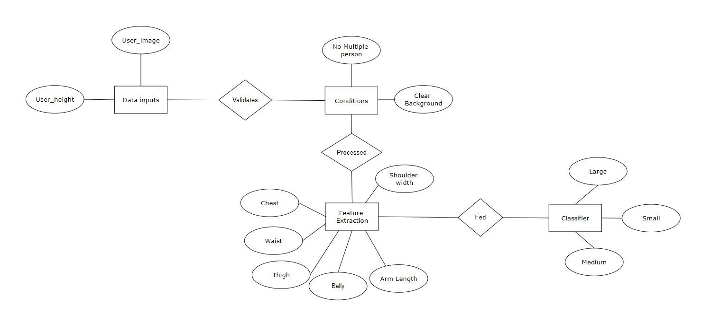

Figure 3.2 - Entity Relationship Diagram

**3.5 Fundamental Model**

Fundamental model of the project gives overall idea about the project. How the entities are related to each other, what are the attributes of the entities, how the data flows between the entities are shown by the fundamental model.

**3.5.1 Data Flow Model**

Data Flow Diagram (DFD) shows graphical representation of the” flow” of data through an information system, modelling its process aspects. It includes data inputs and outputs, data stores, and the various subprocesses the data moves through. DFDs are built using standardized symbols and notation to describe various entities and their relationships.

**DFD LEVEL 0**

Figure 3.3 denotes the Level 0 Data Flow Diagram of the proposed system. It is also known as the Context Diagram. This is the most basic representation of the system. It shows a data system as a whole and emphasizes the way it interacts with external entities. It is a complex representation of the entire system. It displays the most abstract form of a system. It gives a quick idea about the data flow inside the system. There is only one visible process that represents the functions of a complete system. The system for simplification is divided by two entities that make up the level 0 DFD i.e., User, Human Body Size Estimator. There is two-way communication between the user and Human Body Size Estimator. The user uploads a picture and gets the result by the application.

Figure 3.3 – DFD Level 0

**DFD Level 1**

Figure 3.4 shows the Level 1 Data Flow Diagram of the proposed system. It is exactly the same as the Level 0 DFD, but much simplified. The Level 1 DFD shows how the system is divided into subsystems i.e., subprocesses, each of which deals with one or more of the data flows to or from an external agent, and which together provide all the functionality of the system as a whole. It breaks down the main processes and subprocesses that can then be analysed and improved on a more intimate level. The DFD level 0 components are broken down into sub parts where Human Body Size Estimator is divided into Mapping input image into 3D Model, Extracting Body Measurements, Classification of Measurements.

Figure 3.4 – DFD Level 1

**DFD LEVEL 2**

Figure 3.5 shows the Level 2 Data Flow Diagram of the proposed system. It is exactly the same as the Level 1 DFD, but much simplified. The Level 2 DFD shows how the system is divided into sub- sub systems i.e. subprocesses, each of which deals with one or more of the data flows to or from an external agent, and which together provide all of the functionality of the system as a whole. It breaks down the subprocess into subprocesses that can then be analysed and improved on a more intimate level. The DFD level 1 components are broken down into sub parts where Mapping input image into 3D Model, Extracting Body Measurements, Classification of Measurements. In which Classification of Measurements is divided into Small, Medium and Large.

Figure 3.5 – DFD Level 2

**3.6 UML (Unified Modelling Language) Diagram**

The Unified Modelling Language is a general-purpose, developmental, modelling language in the field of software engineering that is intended to provide a standard way to visualize the design of a system. We have prepared and designed the UML diagrams of – Use Case, Activity, Component, Deployment and Sequence Diagrams.

**3.6.1 Use Case Diagram**

Figure 3.6 denotes the Use Case Diagram of the proposed system. It shows the user’s interaction with the systems. The purpose of a use case diagram in Unified Modelling Language (UML) is to demonstrate the different ways that a user might interact with a system. In this use case diagram, there are two actors involved, the first actor is user and the second actor is body size estimator. It depicts the interactions between the various actors used in this system. All these interactions between actors and system is done in the Machine Learning environment. The various use cases involved in this system such as upload photo or capture image and view sizes whose association is between user and body size estimator respectively.

Figure 3.6 – UML

**3.6.2 Activity Diagram**

Figure 3.7 – Activity Diagram

In figure 3.7, we can observe the activity diagram. The two elements are User and body size estimator. First user will be asked to enter his height and to upload image or capture it through web camera. If the image uploaded satisfies the conditions or instruction given such as the image should have plain background and it should be at a specified distance from the camera. If these conditions are not satisfied user will be prompted to recapture the image. After that mapping of the input image into 3d model using SMPL. From this 3d model we’ll extract the body measurements such as shoulder, ankle, waist, chest etc using anthropometric body measurement technique. Finally the measurements will be fed into classification model which will classify it based on standard clothing sizes such as Small, Medium, Large, etc.

**3.6.3 Sequence Diagram**

Figure 3.8 – Sequence Diagram

In figure 3.8, we can observe the sequence diagram. The two elements are User and body size estimator. First user will be asked to enter his height and to upload image or capture it through web camera. If the image uploaded satisfies the conditions or instruction given such as the image should have plain background and it should be at a specified distance from the camera. If these conditions are not satisfied user will be prompted to recapture the image. After that mapping of the input image into 3d model using SMPL. From this 3d model we’ll extract the body measurements such as shoulder, ankle, waist, chest etc using anthropometric body measurement technique. Finally the measurements will be fed into classification model which will classify it based on standard clothing sizes such as Small, Medium, Large, etc.

**3.7 Methodology**

Comparative analysis of existing System:

In existing projects, 3d cameras were used to capture the image. But it would not feasible for everyone to get access to it. It will also increase the cost and processing power of the device. Hence, we working on a model which takes 2D images as input and process it.

Key factors for implementation of project:

* We are implementing this project in the Django so as that the webapp can be used across different platform and so the webapp will be platform independent.
* First, we will implement Home page wherein instruction for capturing images would be displayed.
* After that user will be prompted to grant camera access followed by a prompt to enter the height.

Reconstruction is done through HMR MODEL which is a pretrained model that creates 3D mesh for input image. 3D human body reshaping system consists of three parts, i.e., the Imputer, the Selector and the Mapper in both online stage and offline stage. In offline stage, the Selector takes the dataset of 3D body meshes and corresponding anthropometric parameters as inputs to learn the relevance masks by the proposed feature-selection-based local mapping technique. The mapping matrices are further learned by linear regression from the parameters selected by to mesh-based body representation.

Workflow of the project:

1. Obtaining User input through camera module.
2. Mapping of input image onto 3-dimensional model using 3D human reconstruction.
3. Extracting body measurements from the reconstructed model.
4. Classification of measurements based on size chart.

**Chapter 4**

**Result and Discussion**

This chapter includes the snapshots of the actual outputs that were seen by the user and this chapter also contains the results of the proposed system.

**4.1 Snapshots of project**

Figure 4.1 shows prototype of GUI wherein user need to provide various information along with image.

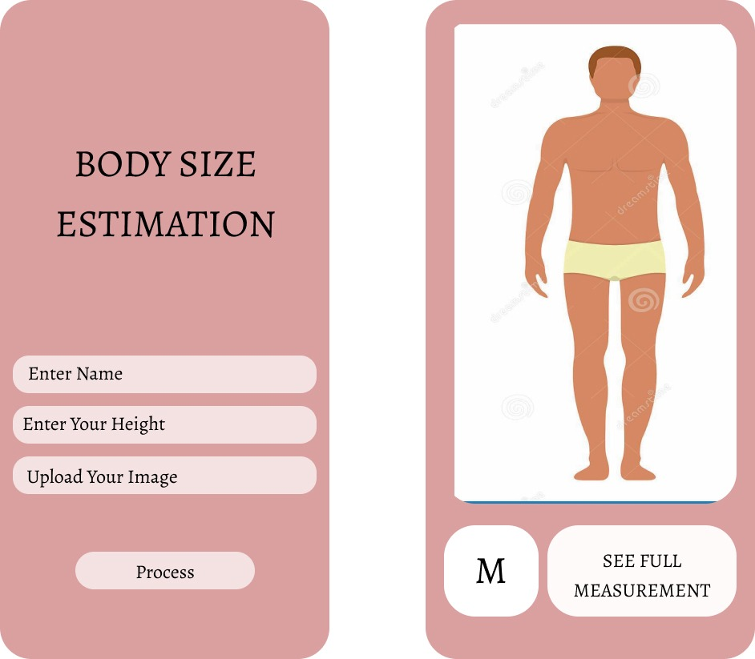

Figure 4.1 – GUI Prototype of Home Page

Figure 4.2 contains the screenshot of the command used to run the code by passing input image



Figure 4.2 – Command for feature extraction of input image

Figure 4.3 contains the screenshot of the output obtained after feature extraction

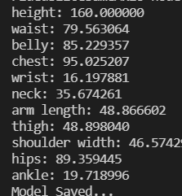

Figure 4.3 – GUI of New Complaint Page

**4.2 Comparison with Existing system**

Table 4.1 – Comparison between existing and proposed system.

|  |  |  |
| --- | --- | --- |
| **Parameter** | **Existing System** | **Human Body Size Estimator** |
| Approach | Use of only one specific approach, either 2D or 3D. | Combination of both 2D and 3D |
| Components required | High tech cameras such as range cameras and scanners | Normal device camera |
| Support for Mobile device | Doesn’t have a mobile appbased approach | As it is a WebApp therefore its platform independent |
| Cost | Expensive due to high tech components | Inexpensive |
| Time | More time | Less time |
| Accuracy | Less | More |

**Conclusion**

In this report, we proposed an approach that aims to improve and facilitate the experience of online shopping through estimate the human body measurements from 2D images by photographing the body using a smartphone camera. To implement the study, we used one of the computer vision pre-trained algorithms to detect the human body in images. The detectors are designed to identify three parts of the human body: one detector used to detect the upper body, another detector used to detect the lower part from the body, and the last detector used to detect the full body. After detecting the body major parts, we will reconstruct it into 3-dimensional model and extract features by segmented each image and determine two points as focal points of each body part to estimate the shoulder width, bust circumference, waist circumference, and hip circumference. After that, several machine learning models that are trained on a dataset consists of measurements for predicting the size of clothes depending on the estimated measurements. Each model will be trained to predicate size a piece of clothing.

**Appendix**

1. https://app.creately.com/

Creately tremendously helped is making the UML diagrams in the project. The various UML diagrams made in the project are – Data Flow Diagrams, Use Case Diagrams and the Entity Relationship Diagrams.

1. PyCharm IDE

PyCharm IDE was used for setting up the entire project.

1. Python 3.6

Python programming language with the version of 3.6 to sync our libraries and make our app compatible on all systems.

1. Dlib

Dlib is a general-purpose cross-platform software library written in the programming language C++. Its design is heavily influenced by ideas from design by contract and component-based software engineering.

1. OpenCV

OpenCV is a library of programming functions mainly aimed at real-time computer vision.

**References**

[1] Wei-Yi Chang, Yu-Chiang, Frank Wang (2015), “SEEING THROUGH THE APPEARANCE”, *Research Center for Information Technology Innovation*, January 2015.

[2] Kaixuan LIU, Pascal Bruniaux, Xianyi, Zeng,Xuyuan Tao (2018), “GARMENT FIT EVALUATIONUSING MACHINE LEARNING TECHNOLOGY”, *Elsevier B.V*, January 2018.

[3] Sahar Ashmawia, Maram Alharbi, Ameerah Almaghrabi, Areej Alhothali (2019), “FITME: BODY MEASUREMENT ESTIMATIONS USING MACHINE LEARNING METHOD”, *Elsevier B.V*, January 2018.

[4] D. M. Anisuzzaman, Md. Hosne Al Walid, A. F. M. Saifuddin SaifAlhothali (2019), “Online Trial Room based on Human Body Shape Detection”, *International Journal of Image, Graphics and Signal Processing (IJIGSP)*, January 2019.

[5] E. Young Kim, Y.K. Kim,“Predicting online purchase intentions for clothing products”, *Eur. J. Market*. 38 (2004) 883–897.

[6] H.K. Song, S.P. Ashdown, “Investigation of the validity of 3-D virtual fitting for pants,” *Cloth. Textiles Res. J. 33* (2015) 314–330.

[7] J. Kim, S. Forsythe, “Adoption of virtual try-on technology for online apparel shopping*”, J. Interact. Mark*. 22 (2008) 45–59.

[8] A.S.M. Sayem, R. Kennon, N. Clarke, “3D CAD systems for the clothing industry”, Intl. J. Fashion Des. Tech. Educ. 3 (2010) 45–53 [10] Mojarrad, M., & Kargar, S. (2013).

[9] Song, D., Tong, R., Chang, J., Wang, T., Du, J., Tang, M., &amp; Zhang, J. J. (2017, June). “Clothes Size Prediction from Dressed-Human Silhouettes”. *In International Workshop on Next Generation Computer Animation Techniques (pp. 86-98). Springer, Cham*.

[10] Sekine, M., Sugita, K., Perbet, F., Stenger, B., &amp; Nishiyama, M. (2014, October). “Virtual fitting by singleshot body shape estimation”. *In Int. Conf. on 3D Body Scanning Technologies (pp. 406-413).*

[11] Parr, J., &amp; Pookulangara, S. (2017). “The impact of True Fit Technology on Consumer Confidence in their online clothing purchase”. Biologi Edukasi. 2014. Penjelasan Golden Ratio Pada Manusia. *Retrieved from :http://www.biologiedukasi.com/2014/08/the-golden-ratio-sebuah-kesempurnaan.html*

[12] Ozturk, S., et al. 2016. Golden ratio: A subtle regulator in our body and cardiovascular system. *In International Journal of Cardiology. Vol. 223,143-145*. Kuriachan, J. K. (2014). Online shopping problems and solutions. NewMedia and Mass Communication, 23(1).

[13] Tan, P. N., Steinbach, M., &amp; Kumar, V. (2016). Premium Website-Bind-in Component Card-For Introduction to Data Mining.

[14] Mitchell, T. M. (2006). The discipline of machine learning (Technical Report CMU- ML-06-108). Pittsburgh.

[15] Redmon, J., Divvala, S., Girshick, R., &amp; Farhadi, A. (2016). “You only look once: Unified, real-time object detection”. *In Proceedings of the IEEE conference on computer vision and pattern recognition (pp. 779-788).*

[16] Misra, R., Wan, M., &amp; McAuley, J. (2018, September). “Decomposing fit semantics for product size recommendation in metric spaces”. ACM.

[17] Torbert, S. (2016). Applied computer science. Springe

**Acknowledgement**

We take this opportunity to express our deep sense of gratitude to our project guide Mr. Ashraf Siddiqui for his continuous guidance and encouragement throughout the duration of our mini project work. It is because of his experience and wonderful knowledge; we can fulfil the requirement of completing the mini project within the stipulated time. We would also like to thank **Dr. Jitendra Saturwar**, Head of computer engineering department and **Mrs. Vishakha Shelke, Mr. John Kenny,** Project Coordinators for their encouragement, whole-hearted cooperation and support.

We would also like to thank our Principal, **Dr. J. B. Patil** and the management of Universal College of Engineering, Vasai, Mumbai for providing us all the facilities and the work friendly environment. We acknowledge with thanks, the assistance provided by departmental staff, library and lab attendants.

**Mr. Shriyash Karekar (42)**

**Mr. Aqueel Alam Khan (45)**

**Mr. Imran Ali Khan (46)**